Project Report
Date | 28 oct 2026
Team ID
Project Name | Global Olympic Sports Performance Analysis
Maximum Marks

1. Introduction

1.1 Project Overview
Global Olympic Sports Performance Analysis studies Olympic medal outcomes for Summer and Winter Games from 1992 to 2026. Four Kaggle CSV datasets are connected in Tableau and presented through two dashboards and a story, which are embedded in a Flask web application.

1.2 Purpose
To help sports organisations, funders and media see which countries, sport categories and regions deliver medals relative to athletes and investment, so that decisions and stories are data-driven.

2. Ideation Phase

2.1 Problem Statement
Three problem statements (PS-1 to PS-3) cover a National Olympic Committee strategist, a sports-fund investment analyst and a broadcast data journalist. See docs/1. Ideation Phase.

2.2 Empathy Map Canvas
Empathy map for the strategist persona (says, thinks, does, feels, pains, gains). See Empathy Map Canvas.docx.

2.3 Brainstorming
Ten ideas were grouped into six themes and prioritised; all six were selected. See Brainstorm & Idea Prioritization Template.docx.

3. Requirement Analysis

3.1 Customer Journey Map
Three stages: define the question, explore the data, decide and act.

3.2 Solution Requirement
Six functional requirements and six non-functional requirements.

3.3 Data Flow Diagram
Level-1 DFD from Kaggle CSVs to the Flask website.

3.4 Technology Stack
CSV, Tableau Desktop, Tableau Public, Python/Flask, Bootstrap.
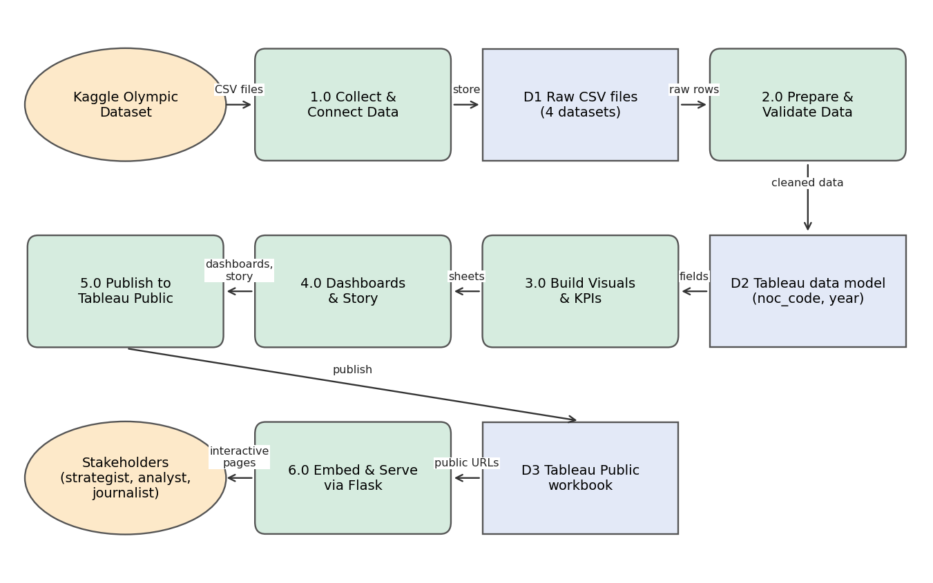

4. Project Design

4.1 Problem Solution Fit
Customer segments, constraints, triggers and channels mapped to the dashboard solution.

4.2 Proposed Solution
Connect, clean, visualise, publish and embed; see the Project Proposal.

4.3 Solution Architecture
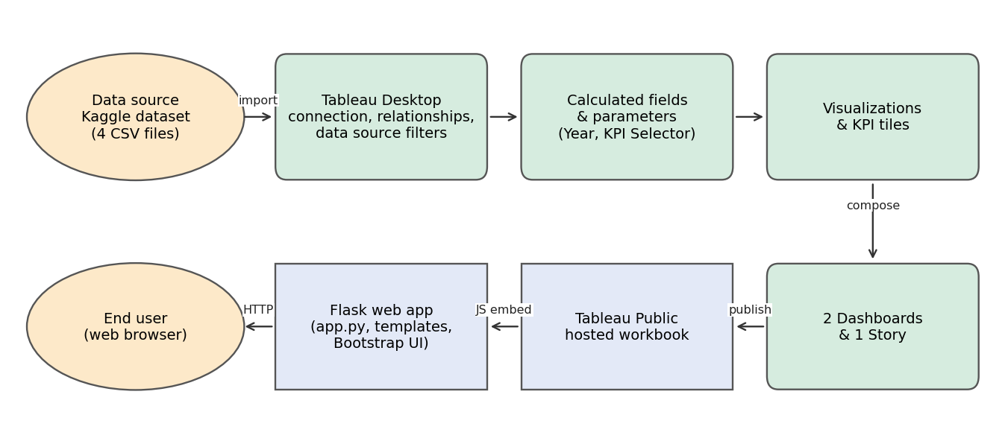

5. Project Planning & Scheduling

5.1 Project Planning
Work was organised into four sprints: data preparation, visualisation and Dashboard 1, Dashboard 2, and story/web/documentation. Sprint dates and completed points:
Sprint | Total Story Points | Duration | Sprint Start Date | Sprint End Date (Planned) | Story Points Completed (as on Planned End Date) | Sprint Release Date (Actual)
Sprint-1 | 8 | 3 Days | 18 Oct 2026 | 20 Oct 2026 | 8 | 20 Oct 2026
Sprint-2 | 12 | 3 Days | 21 Oct 2026 | 23 Oct 2026 | 12 | 23 Oct 2026
Sprint-3 | 11 | 2 Days | 24 Oct 2026 | 25 Oct 2026 | 11 | 25 Oct 2026
Sprint-4 | 11 | 2 Days | 26 Oct 2026 | 27 Oct 2026 | 11 | 27 Oct 2026

6. Functional and Performance Testing

6.1 Performance Testing
Parameter | Result
Data rendered | 8,000 + 910 + 18 + 60 rows across four CSVs; all visualisations rendered within acceptable time
Filters | Country, Year, Sport Category (Dashboard 1); Region, Host Country (Dashboard 2)
Calculation fields | Year extraction; KPI Selector with parameter
Dashboards | 2 dashboards, 10 visualisation groups
Story | 6

7. Results

7.1 Output Screenshots
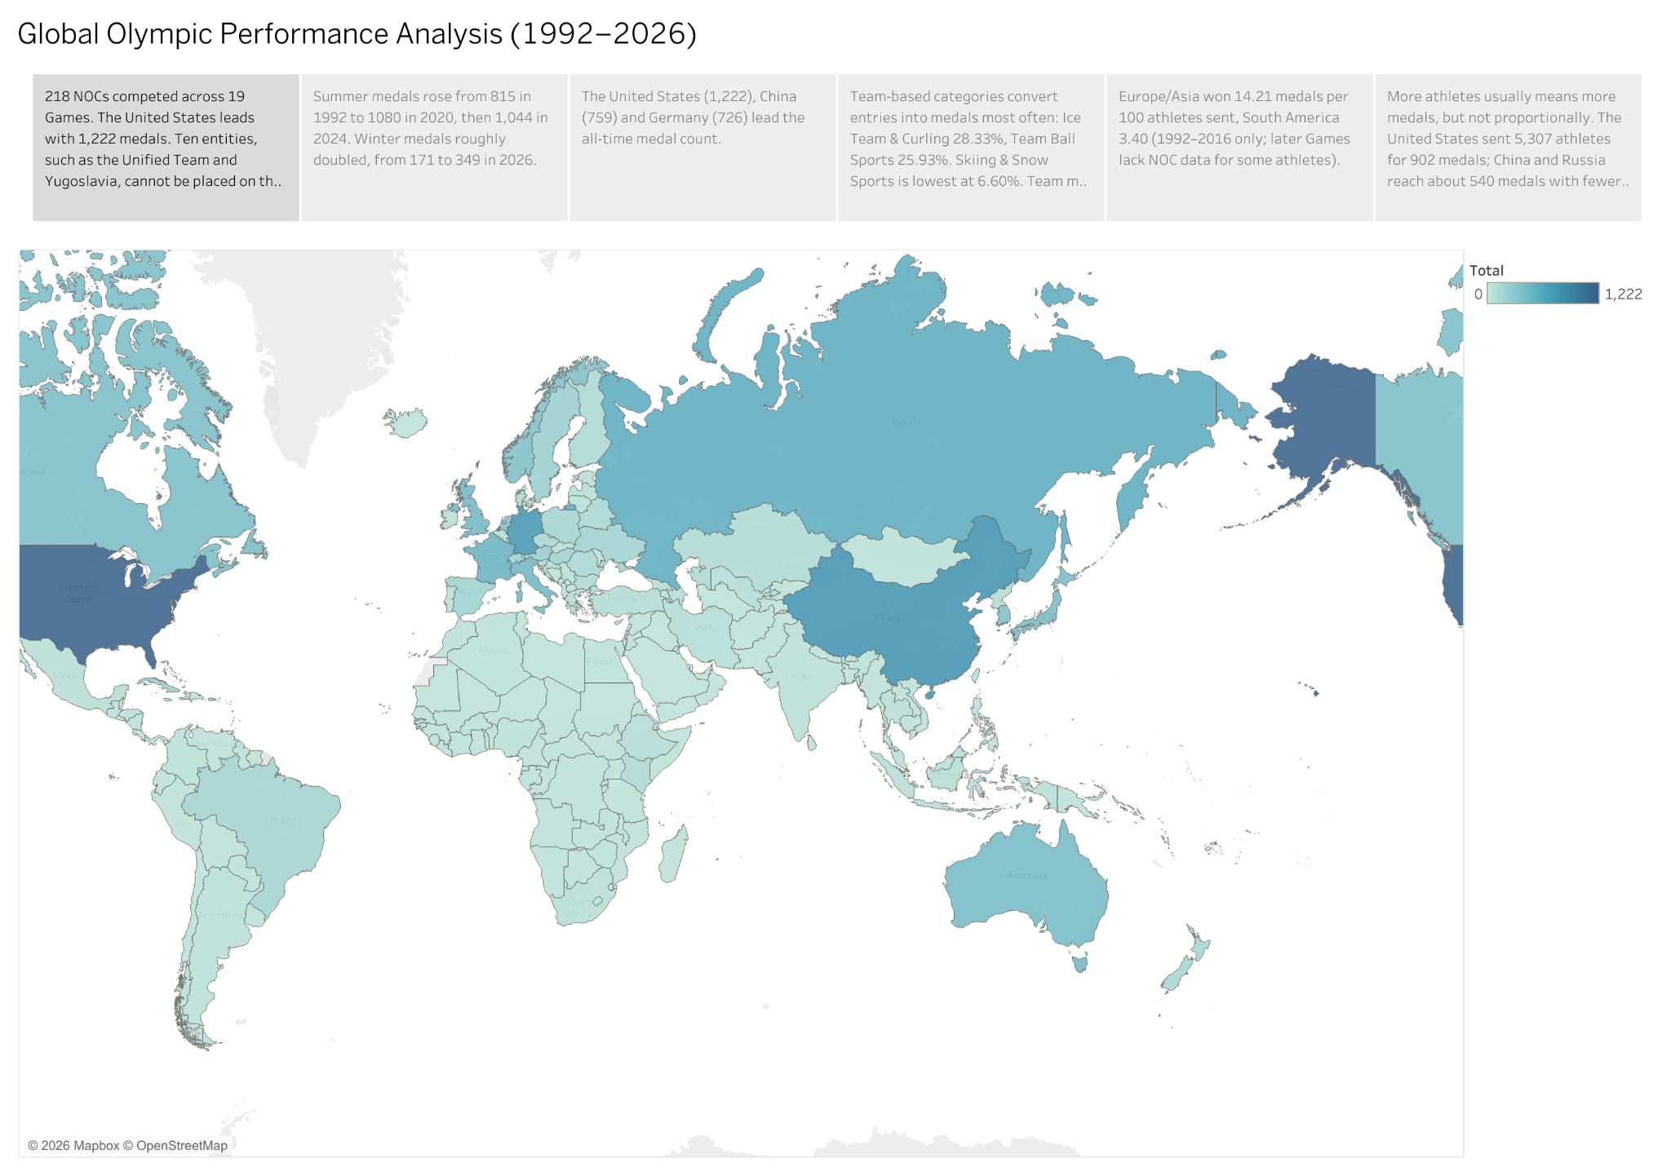
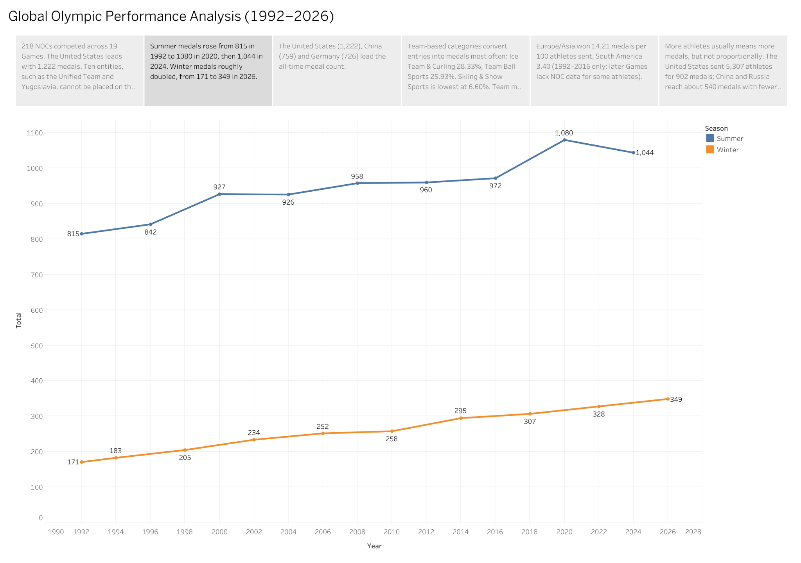
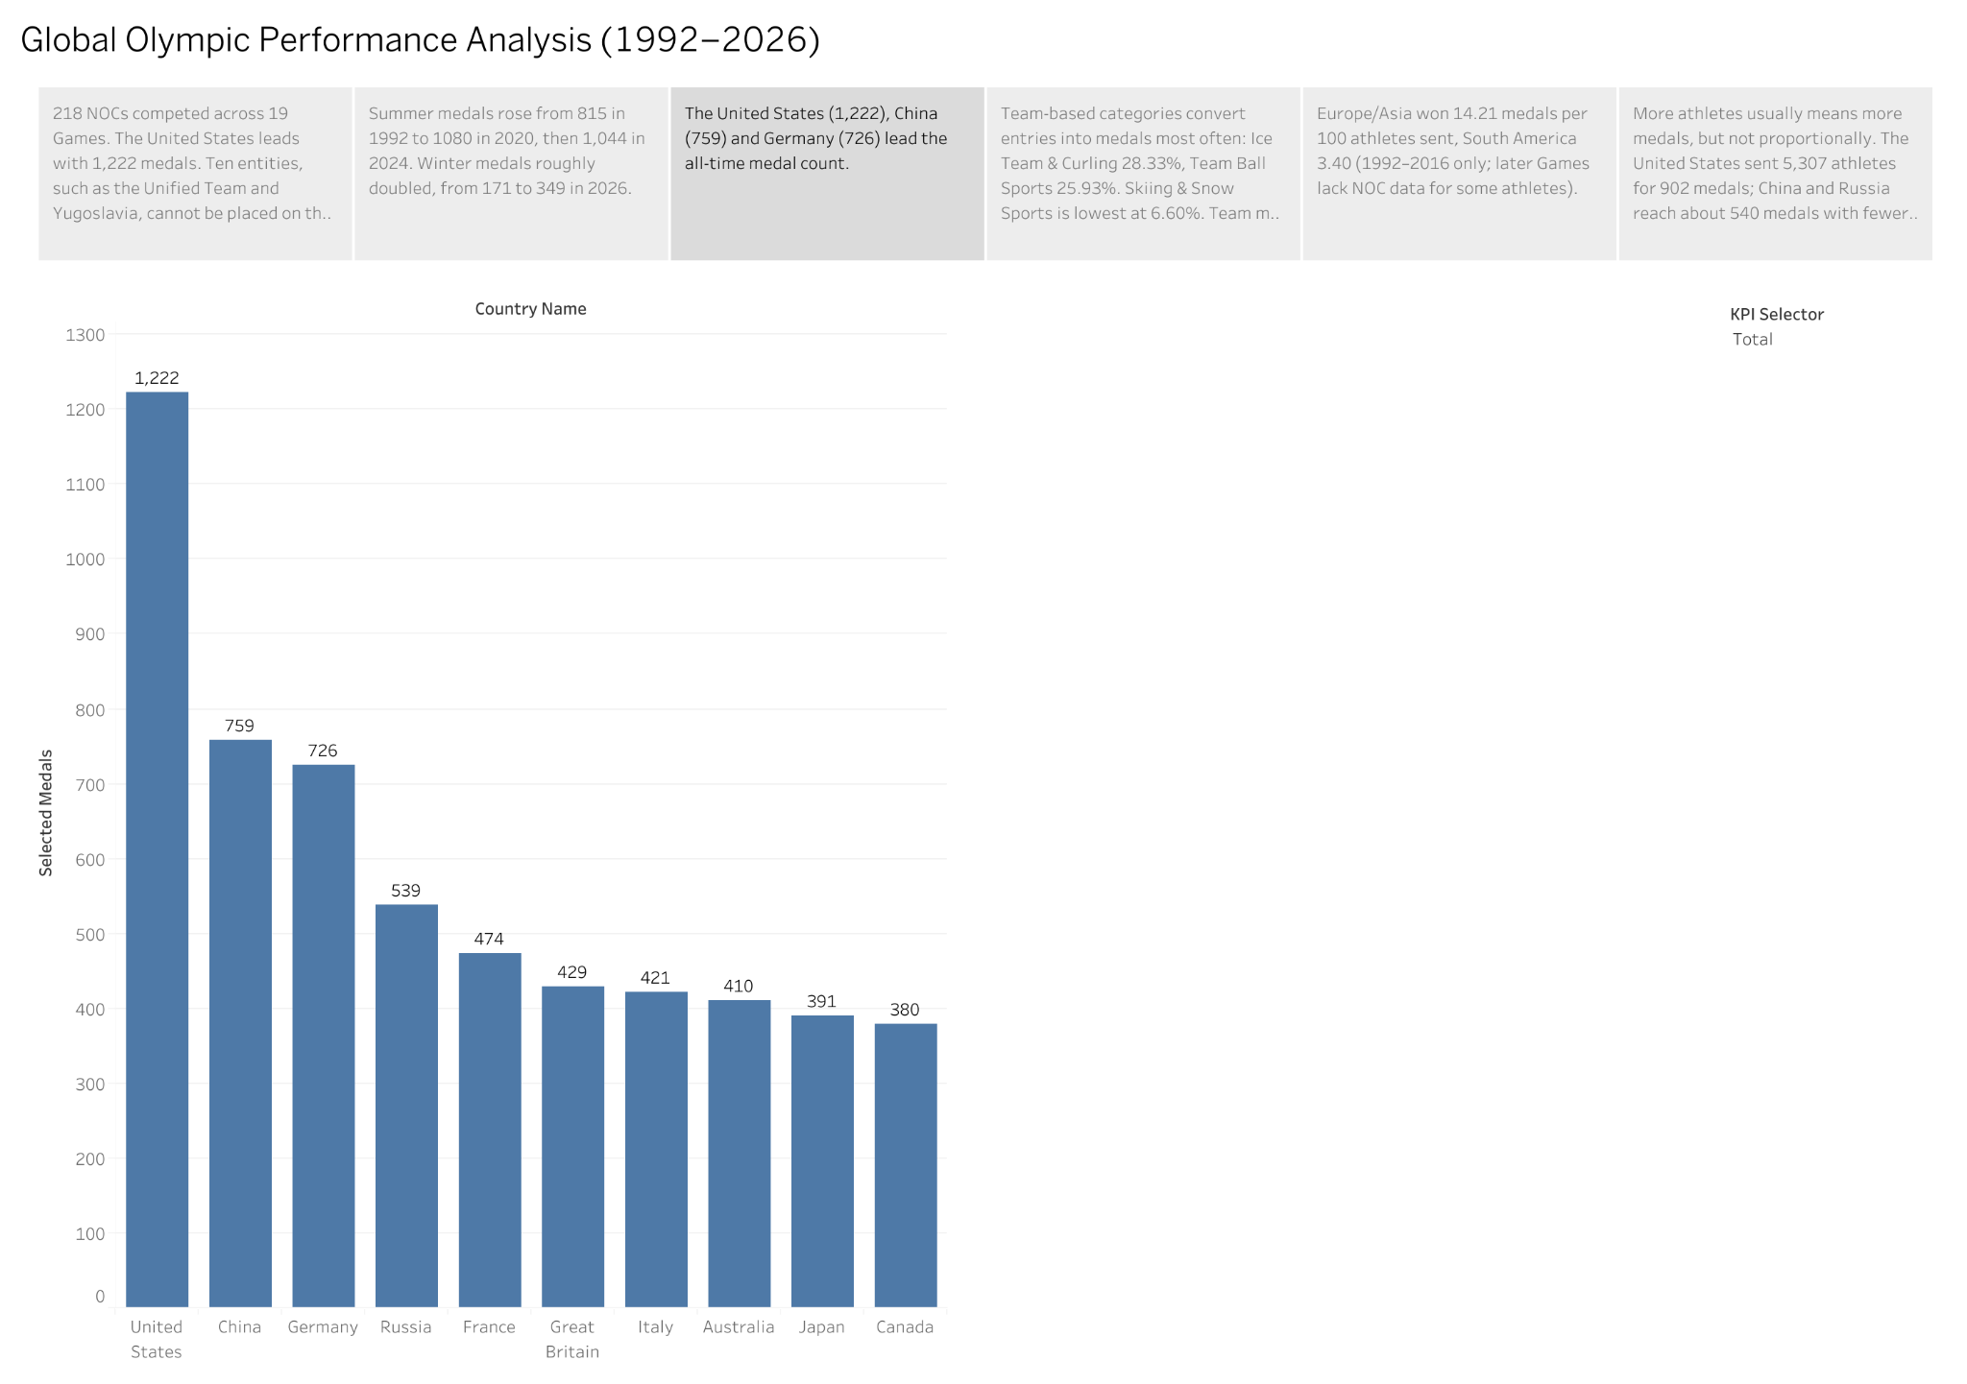
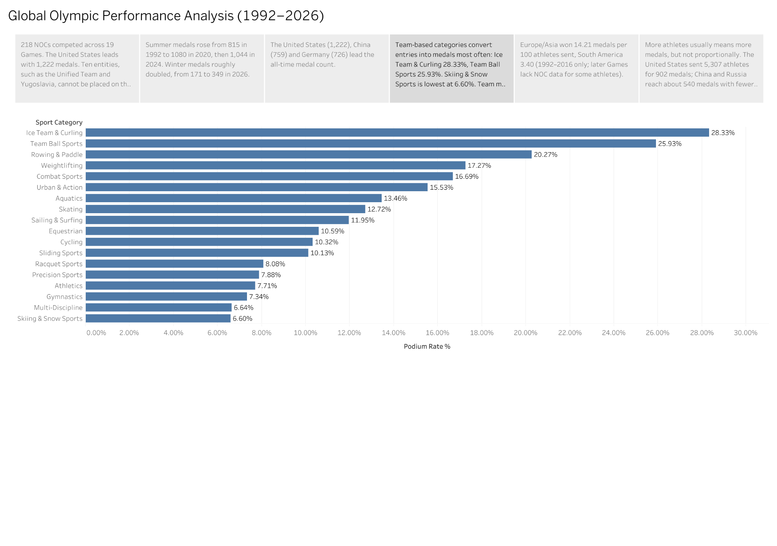
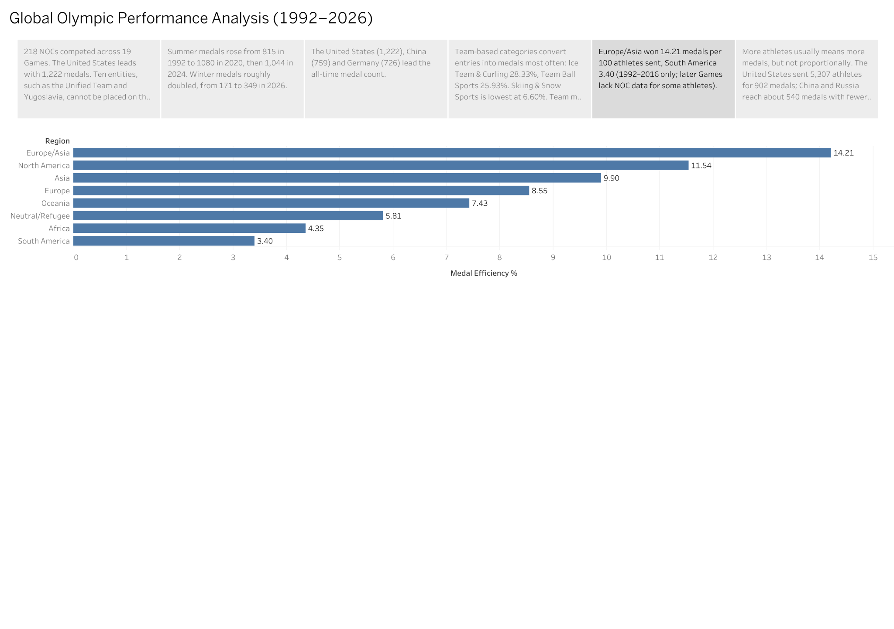
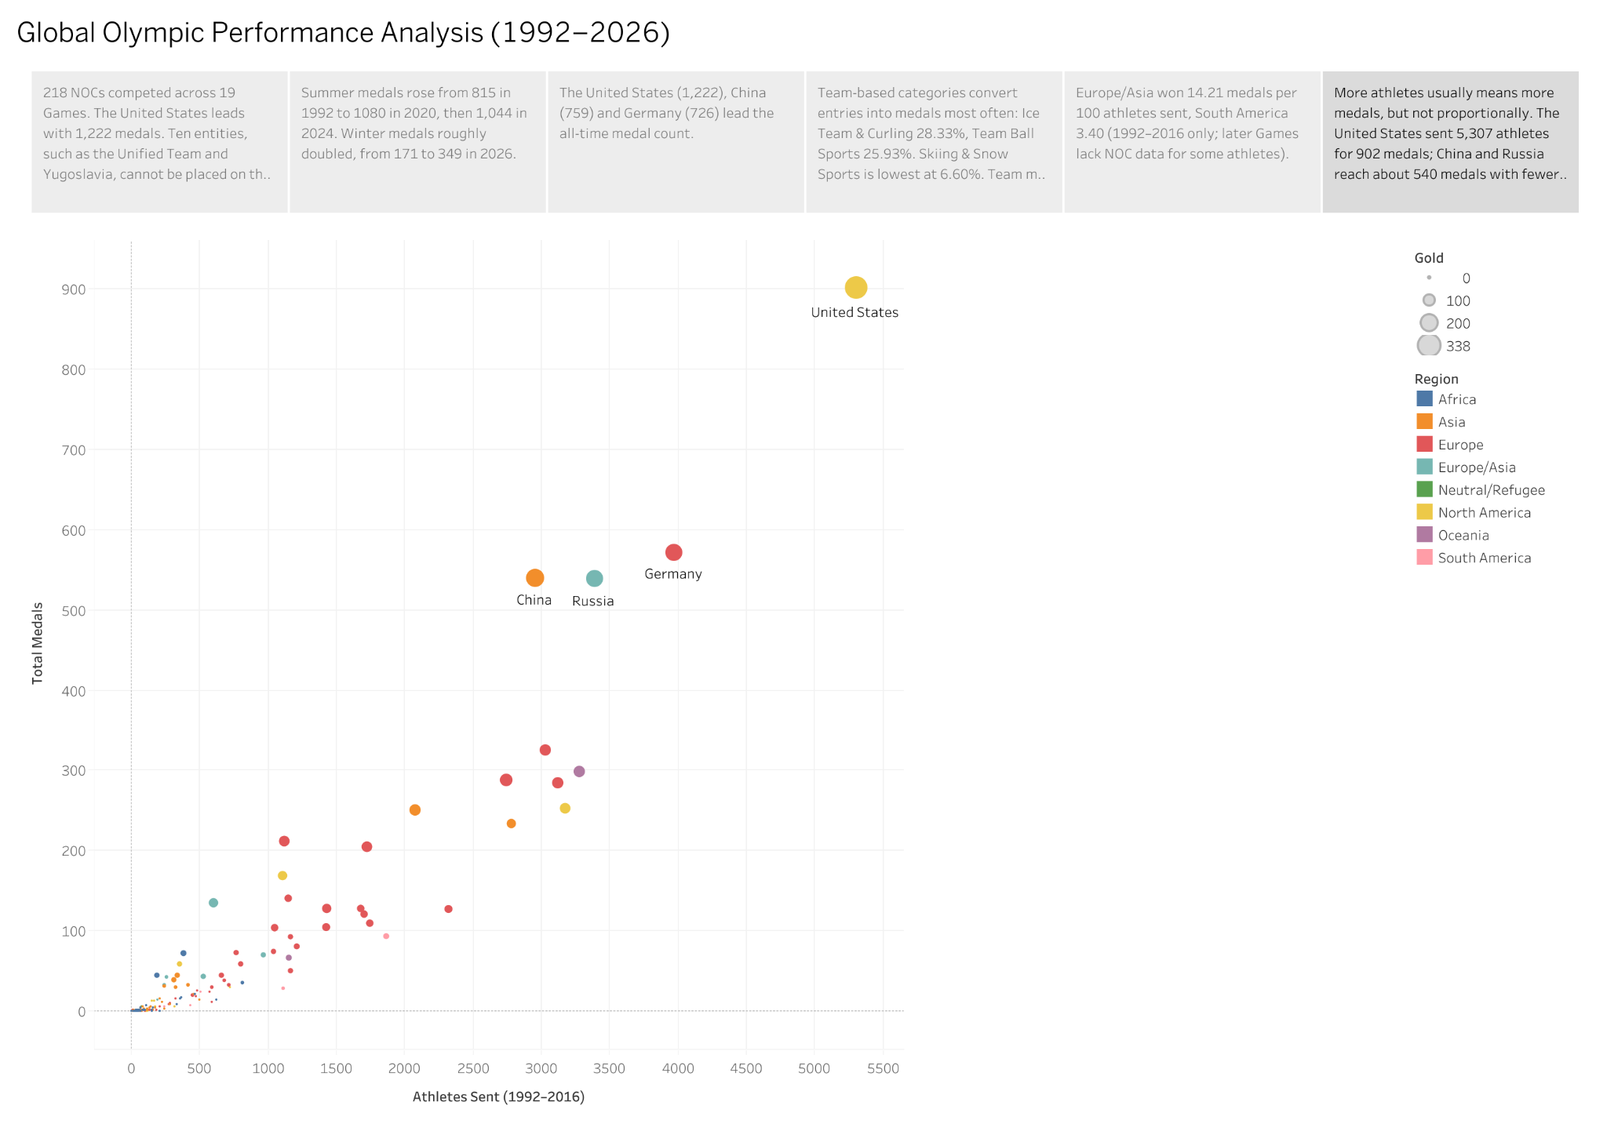

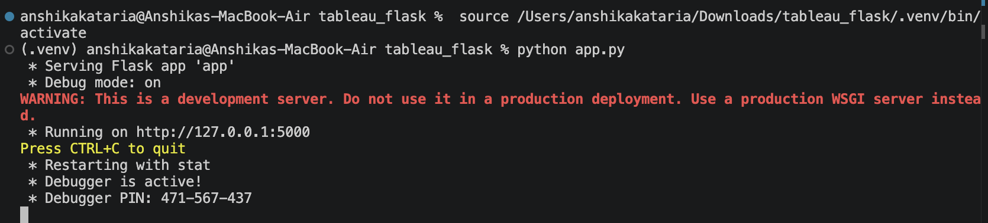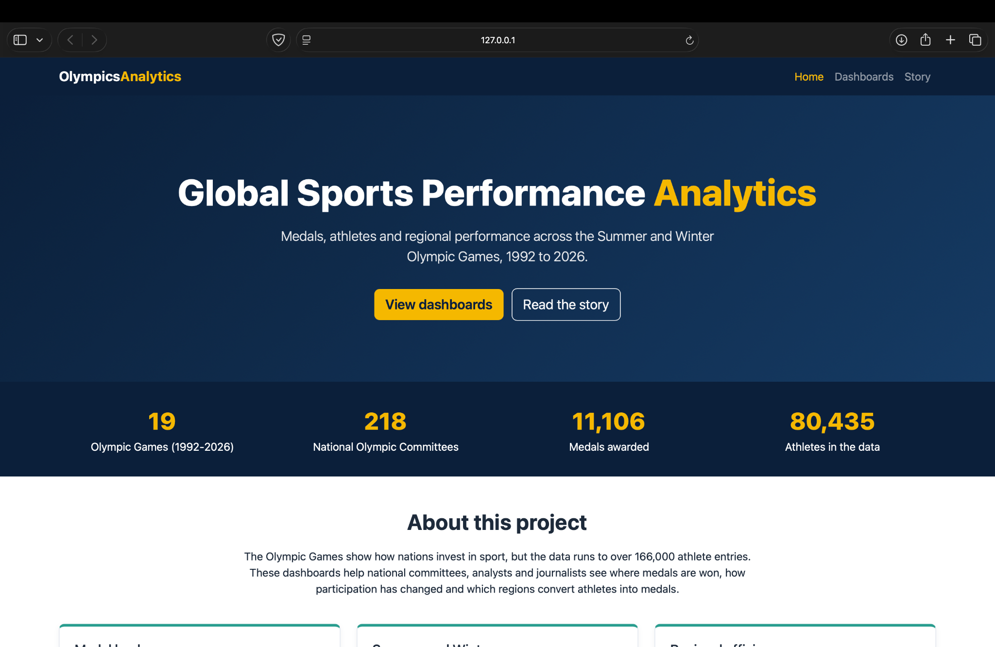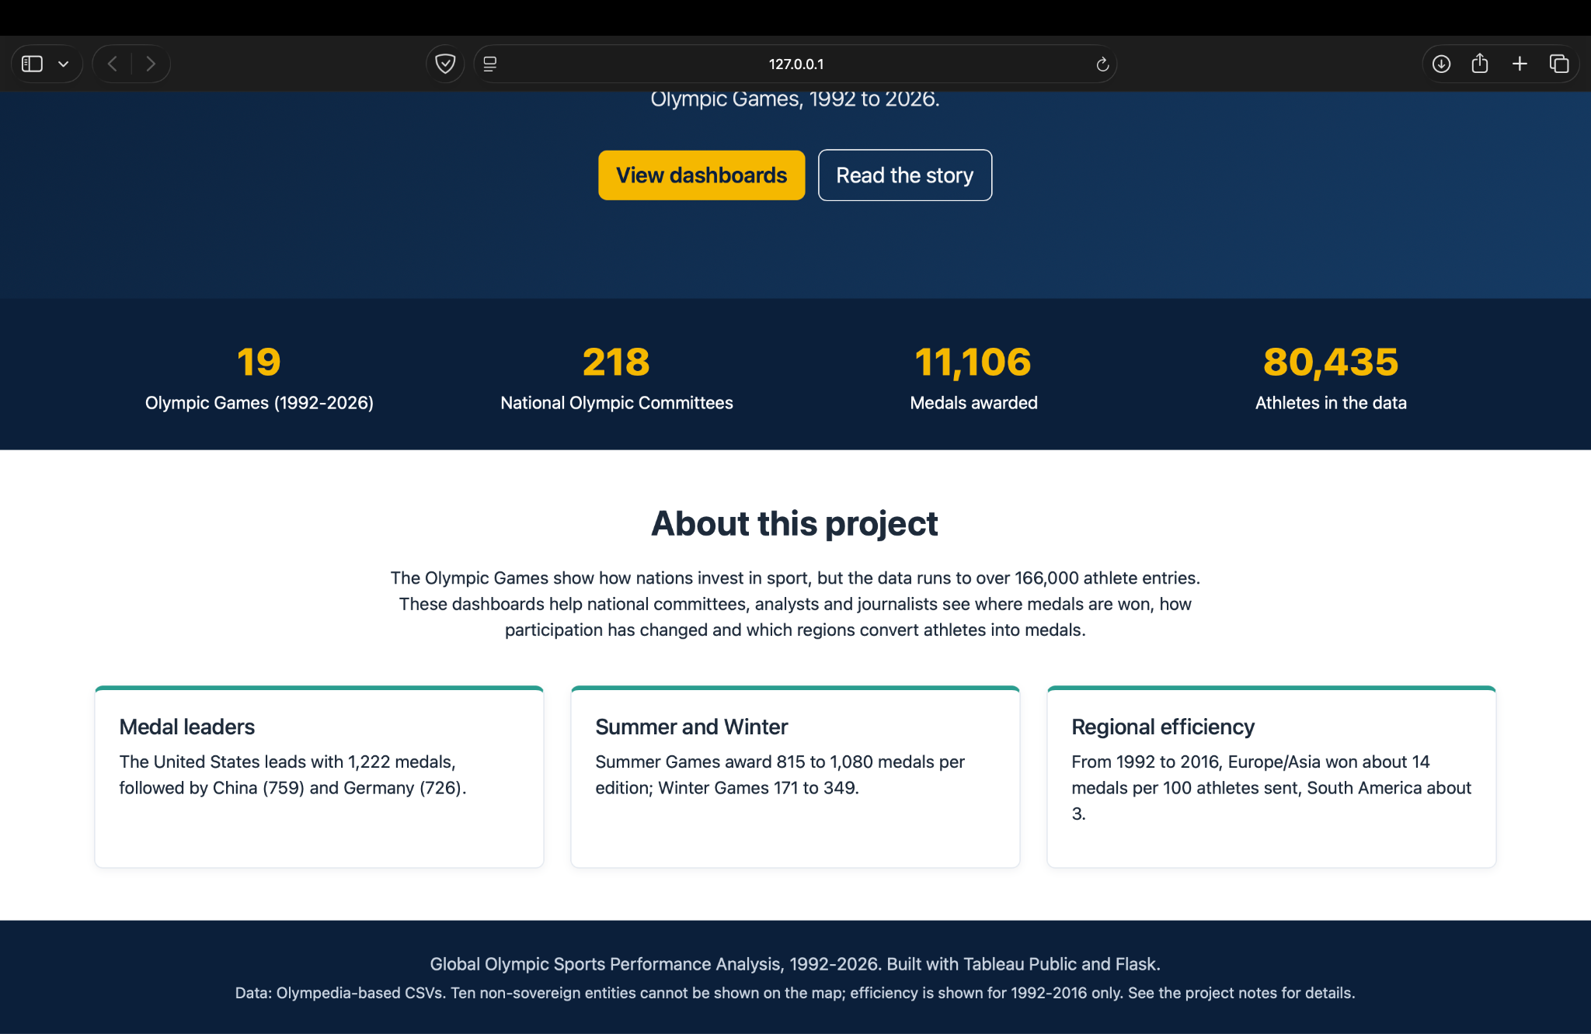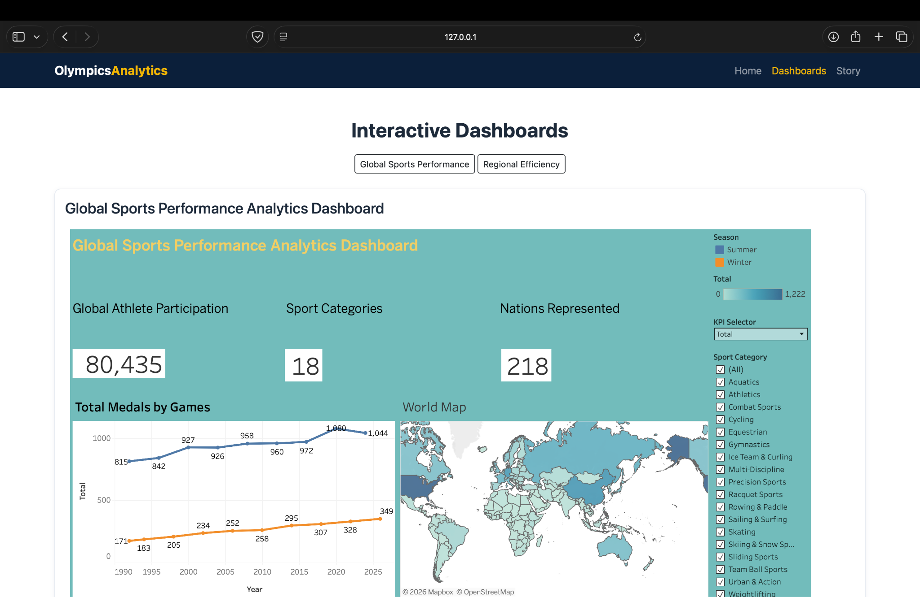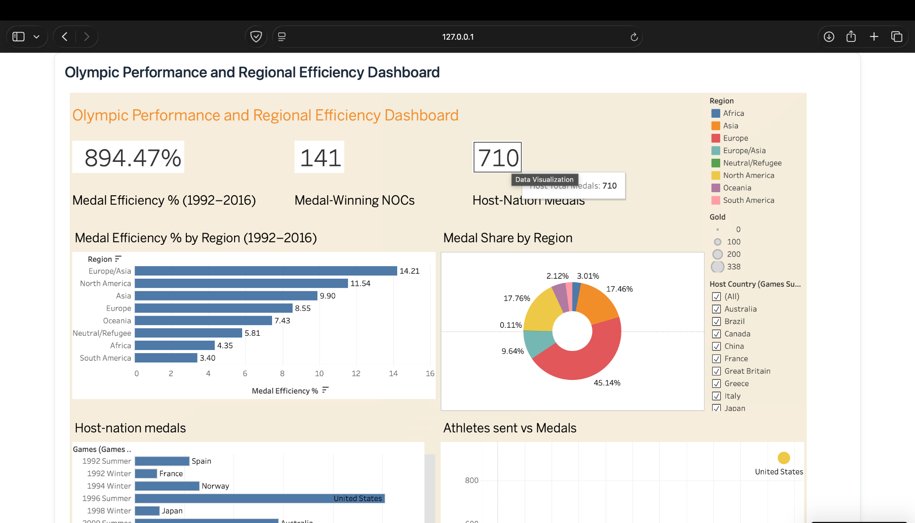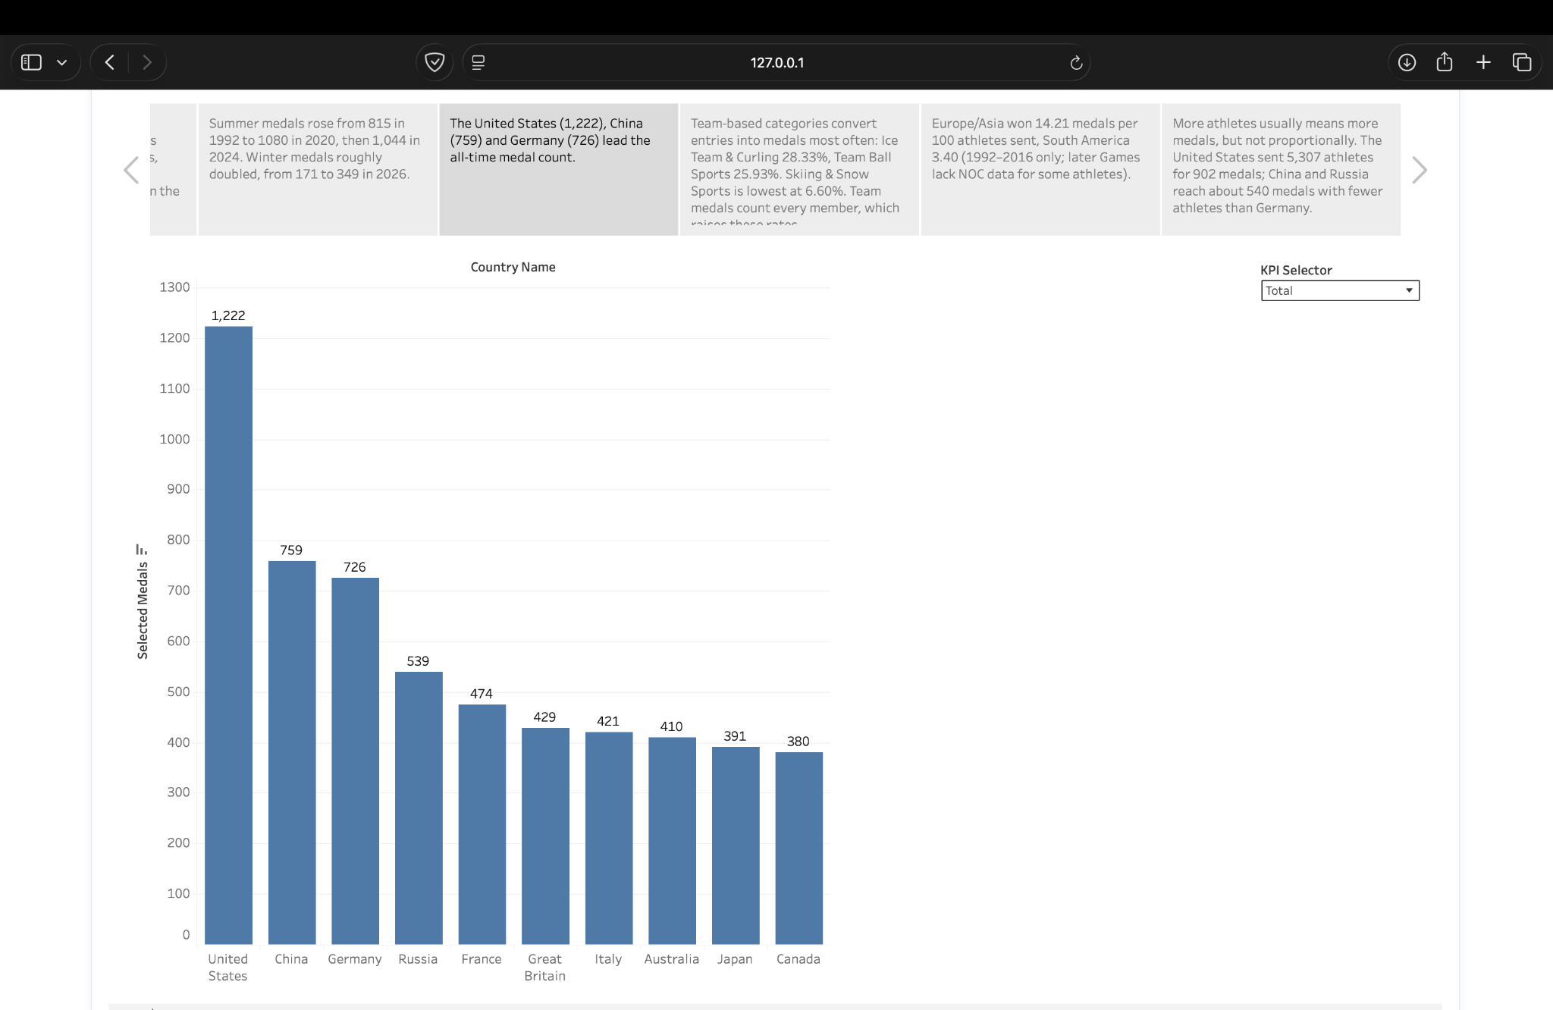

8. Advantages & Disadvantages
Advantages
- Interactive, filterable views of medals, athletes, investment and regions in one place.
- Low cost: free Tableau Public and open-source Flask.
- Reusable for new Games by extending the CSVs.
Disadvantages
- Tableau Public workbooks are public and cannot hold confidential data.
- Flat CSVs are refreshed manually; no live data feed.
- Results depend on the Kaggle dataset's quality; some figures should be verified against official records.

9. Conclusion
The project turns four separate CSVs into a single interactive analysis that supports the investment, funding and storytelling use cases described in the three scenarios.

10. Future Scope
- Add official Olympic data and verify figures.
- Move to a database or Tableau Cloud for scheduled refresh.
- Add predictive models for medal forecasting.
- Add more Games and per-athlete drill-downs.

11. Appendix
- Source code: Flask app in this repository (app.py, templates/, static/).
- Dataset: uploaded csvs
- GitHub link: https://github.com/anshikaktr/Global-Olympic-Sports-Performance-Analysis
- Project demo video link:
- Tableau Public links: https://public.tableau.com/shared/7YNX32BXW?:display_count=n&:origin=viz_share_link (Dashboard1)
https://public.tableau.com/shared/NDRBGKPRD?:display_count=n&:origin=viz_share_link (Dashboard2)
https://public.tableau.com/views/GlobalOlympicSportsPerformanceAnalysis_17932858582970/Story1?:language=en-US&:sid=&:redirect=auth&:display_count=n&:origin=viz_share_link (Story)

